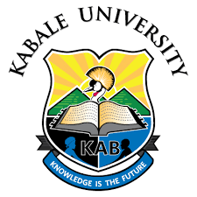

THE WORLD ANTIMICROBIAL RESISTANCE AWARENESS WEEK
“Preventing Antimicrobial Resistance Together”
Workshop Program │ 18th November 2022

Time | Activity | Coordinator/Presenter
8:30am – 8:40am | Arrival and registration
8:40am – 8:45am | Opening Prayer and Introductions | Prof. Manuel Muranga
8:45am – 9:00am | Workshop overview | Irene Mukenya Mutuku
9:00am - 9:10 am | Welcome Note | Dean School of Medicine -KABSOM
9:00am - 9:40 am | Opening Remarks and Launch from: | Vice Chancellor
9:40am – 10:00am | "The impact of Antimicrobial Resistance on Agriculture and the Environment and the efforts towards correcting the problem " | Dean, Faculty of Agriculture and Environmental Sciences
10:00am – 10:40am | Kabale University Antimicrobial Stewardship Club | - Skit  - Presentation  - Dean of Students
10:40am – 11:10am | Antimicrobial Stewarsdhip: "Use of Essential Medicines as a tool to support antibiotic stewardship efforts." | HoD Pharmacology
11:10pm – 11:40am | Case Study Presentation (KRRH Hospital) | Ngabirano Chrispuss
11:40am – 12:00pm | Closing Remarks | Deputy Vice Chancellor Finance & Administration
Lunch break

